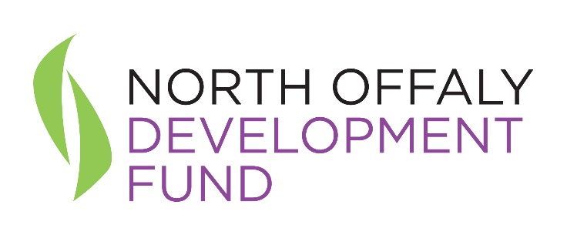
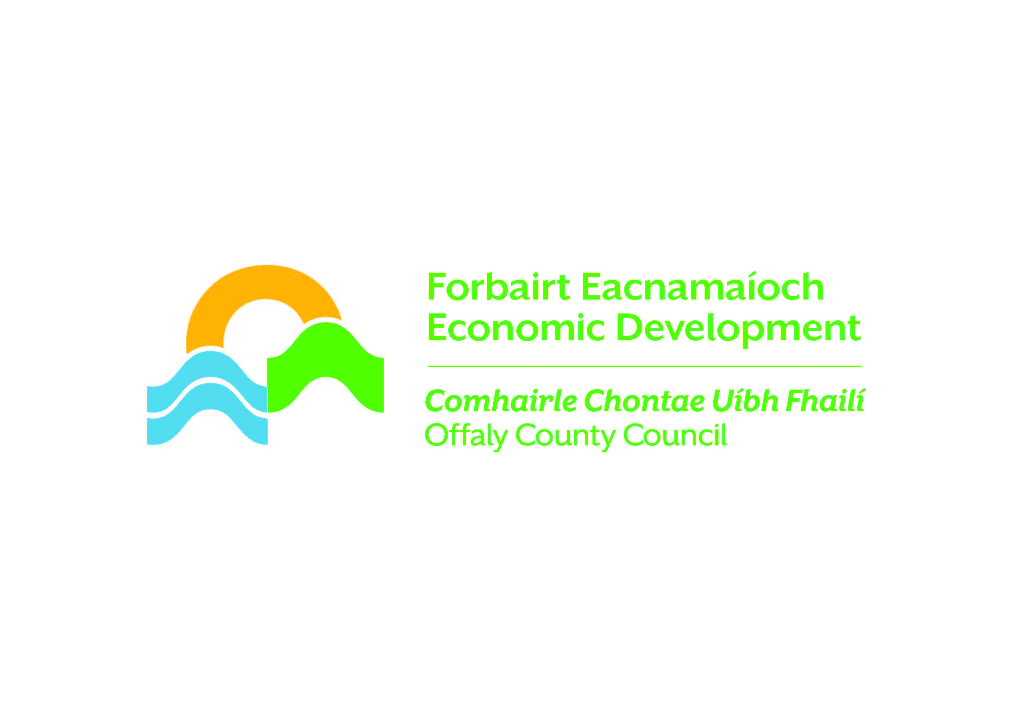

Press Release – For immediate release 12.10.23
New report finds Offaly renewable hydrogen hub could cut carbon emissions by 1,173 tonnes annually

Strategically located where an abundance of renewable energy generation, the national gas network and the electricity grid meet; Rhode Green Energy Park is earmarked to be one of the first hydrogen demonstration hubs in the country.

This is the main finding from the Rhode Renewable Hydrogen Feasibility Study which was commissioned by North Offaly Development Fund Ltd. and Offaly County Council and funded by the Gas Networks Ireland Gas Innovation Fund, as well as funding contributions from SSE Renewables and Bord na Móna.

Aligned with the objectives of the National Hydrogen Strategy published by the Department of Energy and Climate Change in July 2023, the feasibility study focussed on the potential for using curtailed and constrained wind power – excess wind energy – to produce renewable hydrogen through electrolysis.

It is estimated that this proposed one megawatt demonstrator-scale electrolyser will produce 150 tonnes of hydrogen per annum, which is equivalent to 98 MWh of natural gas. One of the recommendations from the study, which was led by RPS with support from University of Galway and University College Dublin, is to inject approximately half of the hydrogen produced into the gas network, while the remainder be used for fueling ‘dual fuel’ (hydrogen / diesel) vehicles. Combined, this will offset an estimated annual CO2 emissions saving of 1,173 tonnes every year¹.

Gas Networks Ireland’s Head of Business Development, Karen Doyle said:
“This study shows the huge potential in Offaly to capture, produce and use more of our renewable energy resources, and how existing state assets, such as Ireland’s €2.7bh gas network can be utilised to enable the decarbonisation of our entire energy system.

Part funded by our gas innovation fund which helps to promote and encourage an environment of innovation in the gas industry, the research shows how the gas network - Ireland’s hydrogen-ready infrastructure and reliable energy backbone - will continue to play a central role in the country’s future clean energy and hydrogen economies.”

Mr. Eugene Mulligan, Chair of North Offaly Development Fund remarked “This valuable and timely study confirms the suitability of Rhode Green Energy Park for cutting edge research and integrated green energy technologies. We have serviced sites available at Rhode Green Energy Park and are developing an Eco-Industrial Park Framework to facilitate growing demand from businesses and investors”.

North Offaly Development Fund has worked in partnership with Offaly County Council on this and other initiatives. Throughout the county, Offaly County Council has taken a lead role in embracing renewable energy in recent years and is examining opportunities in emerging areas including Green Hydrogen and synergies between renewable energy generation, battery storage, large-scale energy usage and spin-off industries.

Ms. Anna Marie Delaney, Chief Executive of Offaly County Council said “Offaly is leading the way in green energy production and innovative green technologies. Our central location provides an ideal base for companies to decarbonise, while serving national and international markets. Offaly County Council is committed to sustainable economic development and the creation of eco-systems for enterprises to co-locate, decarbonise and utilise waste heat and energy for a range of users including industry, horticulture and community benefit”.

This in-depth study was funded by Gas Networks Ireland via the Gas Innovation Fund, with contributions from North Offaly Development Fund, Bord na Mona and SSE. Offaly County Council provided in-kind contributions. RPS led the study and was supported by University of Galway and University College Dublin.

Mr. Alan Curran, RPS Director commented that “This study has identified and costed a clear proposal for a demonstrator project to show how energy systems in electricity, natural gas and transportation can be integrated through the generation of renewable hydrogen. The demonstrator in Rhode is envisaged as a collaborative centre of learning that will advance our transition away from carbon-based fuels. It therefore has a local, regional and national relevance and is very well aligned with the objectives of the National Hydrogen Strategy recently published by the Government”.

This 1MW demonstrator-scale electrolyser has relevance to other locations around Ireland and is envisaged as a project that can be replicated elsewhere and expanded modularly.

The full report is available to read at https://www.offaly.ie/app/uploads/Work/1IE000207_Rhode-Hydrogen-Feasibility-Study_Final-Report_A1-C01_06_09_2023.pdf

¹ Rhode Renewable Hydrogen Feasibility Study - Section 10.2; page 93

ENDS

For further information on this report and business opportunities in Offaly, please contact
Orla Martin, Head of Enterprise, LEO Offaly, Offaly County Council
orla.martin@leo.offalycoco.ie
Green Energy & Technology - Offaly County Council

Photographs:
Project Partners: Representatives from Offaly County Council, North Offaly Development Fund, RPS, Bord na Móna, University of Galway, SSE and Gas Networks Ireland (GNI).

Wider Group: Representatives from Offaly County Council, North Offaly Development Fund, RPS, Bord na Móna, University of Galway, SSE, IDA, Dept. of Environment, Climate and Communications, Gas Networks Ireland Ltd.
Background / Notes to the Editor

Background
Rhode Green Energy Park
Due to the closure of the power station in Rhode, Co. Offaly the North Offaly Development Fund (NODF) was established with the objective to benefit the community of Rhode and surrounding area. In particular, NODF is intended to assist enterprise creation and development, with the aim of increasing employment and enhancing the economic and social profile in the area. The company received its funding from ESB Networks.
The development of the Rhode Business Park was originally initiated by NODF for enterprise development for the benefit of the local economy and local community. Redevelopment of the site as a Business Park was approximately 90% complete in 2008 when, due to the on-set of the recession this work stopped. NODF had by this time invested €1.8million developing the park and Offaly County Council had invested €0.9 million developing the access infrastructure.
In 2020, Offaly County Council commissioned an Opportunity Assessment Report that reviewed the existing activity in the area with a particular emphasis on green energy and the energy transition. The report identified a number of enterprise and employment opportunities for North Offaly, focussed on the Rhode Green Energy Park. A subsequent Feasibility Study on Data Centre Integration with Renewables and Hydrogen was undertaken by Siemens and released in March 2023.
Offaly County Council subsequently secured close to €1m to completion and transform the park infrastructure, enabling these opportunities to be developed. This will include integration of renewable energy with industrial and business employment.

