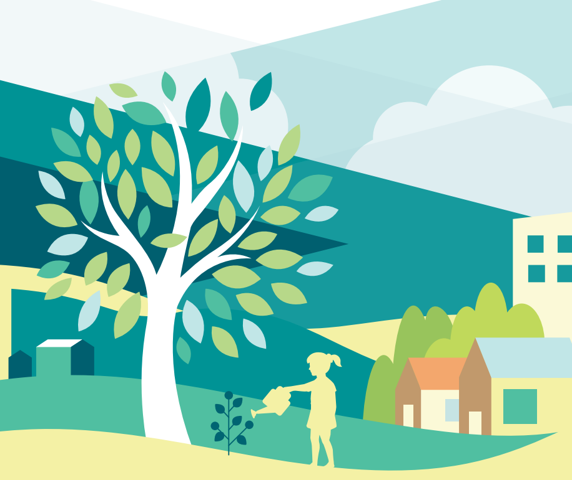

Offaly Local Community Development Committee has commenced the process of preparing a new Local Economic and Community Plan (LECP) 2023-2028. This will build upon and replace the previous Plan, which covered the period 2016 – 2021.
The new LECP will set out the objectives and actions which are needed to promote and support the economic development and the local and community development of County Offaly.
Offaly County Council has now completed Stage 1 of the process and has produced the Draft Socio-Economic Statement and High-Level Goals document.

We are asking for your support to review this document and provide your views and opinions to help shape the future of the economy and communities in Offaly by completing this questionnaire. The questionnaire contains 28 short questions and should take no more than 15 minutes to complete.

All feedback will help further develop the High Level Goals and help develop an Implementation plan.

We encourage you to get involved to help shape our county for the better!
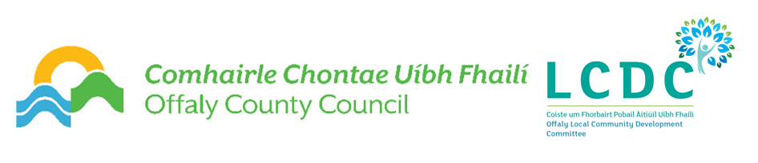

Registration Details

Name
Email Address
Tick which Municipal District you are based within: | Tullamore
 | Birr
 | Edenderry
Please indicate your Area of Residency (e.g.) Pullough, Shinrone, Clonbullogue, etc.
Please indicate which category best describes your status | Community Group / Organisation
 | Social Enterprise
 | Commercial Enterprise
 | Private Individual
 | Other (specify)

Our LECP High Level Goals cover 4 key themes. The number of questions in each theme is shown below:

1) Sustainable Communities (9) 2) Economic Opportunity (4)
3) Healthy Placemaking (8) 4) Climate Action (7)

1) Sustainable Communities (9 Questions)
Create safe, accessible and resilient communities that will be better able to react to future threats and thrive into the future.

What are the most important community priority areas and concerns for you over the next six years?

Are supports and services in Offaly accessible to most, or is there a section of society that is missing out? (e.g. access to childcare, 3rd level, disability services)

How can we ensure that the community has the information they need to engage with key agencies?

How can we partner with people in the community to support community development on the ground?

What additional arts and culture programmes or events would you be interested in seeing or participating in?

How can we help everyone to feel safe and welcome in our communities?

What do you think would make Offaly a more attractive place to live, work or visit?

How often do you use the following services in your community?
 | Very Often | Often | Sometimes | Never | No Opinion
Community facilities in your area

Sports Facilities in your area

Tourism amenities in your area

Public transport in your area

What are the biggest challenges facing you / your organisation / community group or the people that you work with? (tick box)
 | Big  Challenge | Less of a  challenge | Not a  Challenge
Retaining staff / volunteers
Funding, match funding, access to finance
Organisation Capacity
Having a say in local decision-making
Cost of living (Energy)
Cost of living (Food)
Availability of public transport
Insufficient community services/facilities
Buildings and homes not energy efficient

2) Economic Opportunity (4 Questions)
Promote economic and enterprise development in the county

What are the most important economic priority areas for you over the next six years?

How can we attract, support and retain new business and create jobs, especially in the disadvantaged areas of the county?

How can we better support new business start-ups, entrepreneurship, and social enterprises?

How can we grow the local economy across all of Offaly?

3) Healthy Placemaking (8 Questions)
To ensure healthy lives and promote wellbeing for all ages in all areas of the county

What community infrastructure, facilities and services should we prioritise and where?

How can we encourage our communities to adopt healthy lifestyles by engaging in physical activity, positive mental health initiatives and healthy eating?

What additional services or supports are needed for older people?

What type of mental health and well-being supports are the most important for our communities?

Do you have problems accessing services due to lack of transport options?

Are there sufficient playgrounds or recreational space for children and adults in your community? What additional services are needed?

Are there additional supports and services needed for young people? What are they?

How can we improve access to services for people with disabilities?

4) Climate Action (7 Questions)
Create a sustainable economy and sustainable communities that will be supported to act on climate

What’s stopping you from reducing the amount of material in your waste and recycling bins?

How could you reduce the number of car journeys you make each week?

How can you improve the efficiency of your home when it comes to heating and electricity use?

Apart from money are there any other barriers preventing you from making your home more energy efficient?

What sorts of environment and climate initiatives would you be interested in participating in?

How can communities be supported to take action on climate?

What measures would encourage you to switch to an electric car?

FINAL QUESTION
Do you have any other observations in relation to the new Local Economic and Community Plan for County Offaly?

Offaly County Council is subject to the requirements of the Freedom of Information Act, 2014, the Data Protection Act, 2018 and to the General Data Protection Regulations (GDPR). All responses will be stored in compliance with GDPR. Offaly County Council GDPR policy and Privacy Policy is available on our website.

Offaly County Council would like to thank you for taking the time to complete this survey. This information will be used for the development of the new Local Economic and Community Plan 2023-2028

If you have further questions about the Offaly County LECP 2023-2028, please contact a member of the team at lecp@offalycoco.ie
THANK YOU

