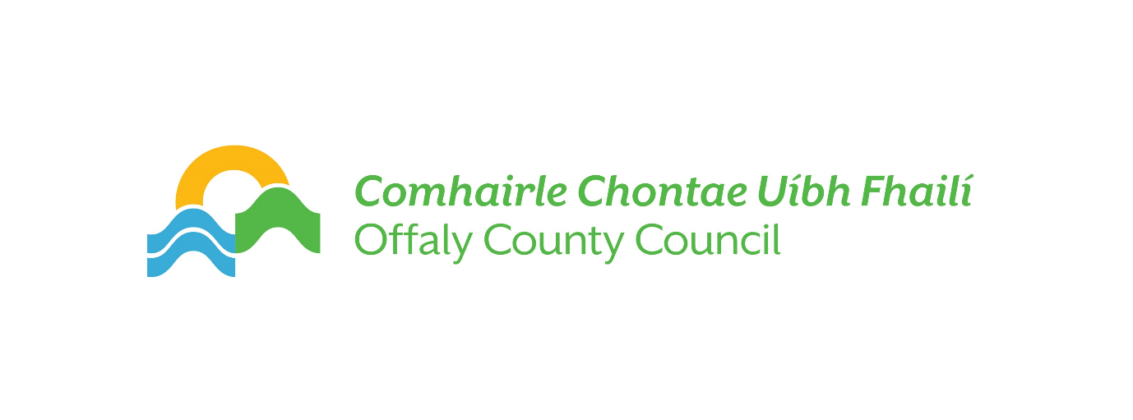

How to make a Data Subject Access Request (SAR) -   
Subject Access Request Form

Request for Access to Personal Data under the (EU) General Data Protection Regulation and the Data Protection Acts, 1988 to 2018.

**Please Note:**

1. **A Request in writing must be made and signed by the applicant.**
2. **Proof of Identity: A legible photocopy/scanned copy of proof of identity e.g. passport or driver’s licence is required.**
3. **Proof of Address must accompany this Subject Access Request form e.g. a legible photocopy/scanned copy of a utility bill or Government letter with your name on it dated within last 6 months.**
4. **Within the terms of the General Data Protection Regulation, Offaly County Council will respond to your request for personal data within one month. In some circumstances where requests are complex or numerous, this period may be extended**
5. **Where a request is manifestly unfounded, excessive, of a repetitive nature or where more than one copy is sought, a fee may apply.**
6. **Offaly County Council’s Privacy Statement is set out at the end of this form.**
7. **If the application is being made through a solicitor, a signed form consenting to the release of data to solicitor is required.**
8. **Third party requests by parent/guardian requires their identification documents.**



**Request for a copy of Personal Data**

General Data Protection Regulation and Data Protection Act 2018

**Please complete all parts**

|  |  |  |
| --- | --- | --- |
| 1 | Full Name |  |
| 2 | Postal Address (preferably including Eircode) |  |
| 3 | Telephone Number: |  |
| 4 | Email Address: |  |
| 5 | Please outline details of the data sought. |  |
| 6 | To assist us in locating the data requested, please indicate the location within Offaly County Council, where you believe your personal data may be in existence. |  |
| 7 | Please indicate the time period for which the data being sought relates to. |  |
| 8 | Please provide any previous reference numbers relating to your contact with Offaly County Council |  |

**Verification of Identity**

In order for us to verify your identity, please provide the following information. A copy of Photo ID i.e. Passport or Driving Licence and a copy of a recent Utility Bill or Government letter issued within the last six months to your current address.

I, [insert name] declare that all the details I have provided in this form are true and complete to the best of my knowledge.

Signed: ____________________________ Date:__________________________________

Please return this form to: **Data Protection Officer, Offaly County Council, Áras an Chontae, Charleville Road, Tullamore, Co. Offaly. R35 F893 or by e-mail to** [**dpo@offalycoco.ie**](mailto:dpo@offalycoco.ie)

**Further information on Data Protection Subject Access Requests can be found on the website of the Data Protection Commission –** [**www.dataprotection.ie**](http://www.dataprotection.ie)

**Checklist**

Have you:

1. Completed the Subject Access (SAR) Request form in full - YES/NO
2. Signed and dated the Declaration on the SAR form - YES/NO
3. Included an appropriate form of Photo ID - YES/NO
4. Included a copy of a recent utility bill or Government letter - YES/NO
5. Included letter of consent to Solicitor (where applicable) - YES/NO

***If you have ticked No to any question above we regret we cannot process your request.***

**Privacy Statement**

Offaly County Council processes all personal information in accordance with the General Data Protection Regulation and the Data Protection Acts, 1988 to 2018. Further information in relation to this is available on our website at: <https://www.offaly.ie/eng/Privacy-Statement>