Expression of Interest Form
Outdoor Recreation Infrastructure Scheme 2023

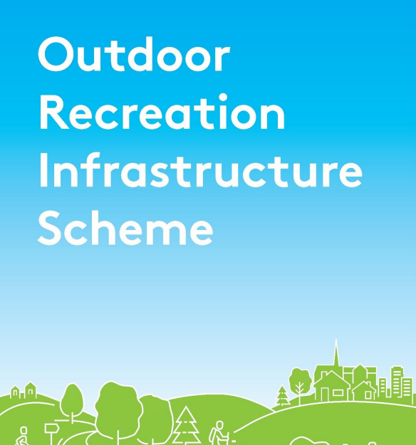
Outdoor Recreation Infrastructure Scheme 2023

Please read the ORIS Scheme Outline 2023 before completing this form.
Please complete this Expression of Interest form and
return it to Offaly County Council clearly marked ORIS.

Project name:

Please indicate which category of funding is being applied for:

Measure 1 - Up to €30,000

Small Scale Repair/Development/Promotion and Marketing

Measure 2 - Up to €200,000

Medium Scale Repair/Upgrade and New Trail/Amenity Development

Measure 3 - Up to €500,000

Strategic Large Scale Repair/Upgrade and New Strategic Trail/Amenity Development

Project Development Measure - Up to €50,000

Development Costs for Strategic Large Scale Projects

Amount of Funding Requested:

Applicant Group:

Applicant Contact Name:

Applicant Contact Address:

Applicant Telephone Number:

Applicant Mobile Number:

Applicant Email Address:

- Has funding for this project ever been sought from other sources? ☐ Yes ☐No
(If "YES" yes please specify from what source and if funding was provided)

- Who are the specific project stakeholders/community partners in this project?
(Coillte, Born na Mona, Chamber of Commerce, Community group, etc.).

- Project details, including detail map of location:
- If seeking funding for Measure 2/3 - €200,000 or €500,000, please detail the particular case for this level of funding, including planning permission secured, ecological surveys complete, landownership agreements.

- If applying for Project Development Measure please provide a synopsis of the proposal, detailing the intervention envisaged and the works proposed. Include a summary of the Measure 2/3 project that will be developed as a result of the completion of the Project Development proposal:

- What is the objective of the proposed project and how will the intended outcomes be measured? (Please identify any metrics or benchmarks that will be applied).

DECLARATION
I hereby confirm that I have read and understand this document. I request that consideration be given in support of the project as outlined above.

I understand there is no guarantee by submitting an expression of interest that the application will be successful at this time.

Signature __________________________________________________

Position __________________________________________________

Date __________________________________________________

