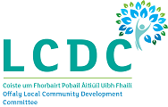

Offaly Local Community Development Committee (LCDC)

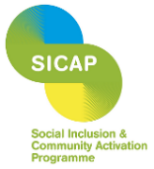
Social Inclusion and Community Activation Programme (SICAP) 2024-2028
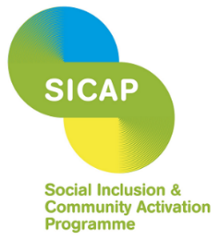
The Social Inclusion and Community Activation Programme (SICAP) is co-funded by the Irish Government, through the Department of Rural and Community Development, and the European Union through the European Social Fund Plus under the Employment, Inclusion, Skills and Training (EIST) Programme 2021-2027.

Tá an Clár um Chuimsiú Sóisialta agus Gníomhachtú Pobail (SICAP) cómhaoinithe ag Rialtas na hÉireann, tríd an Roinn Forbartha Tuaithe agus Pobail, agus ag an Aontas Eorpach trí Chiste Sóisialta na hEorpa Plus faoin gClár Fostaíochta, Cuimsiú, Scileanna agus Oiliúna (EIST) 2021 -2027.

The Social Inclusion and Community Activation Programme (SICAP) 2024-2028 provides funding to tackle poverty and social exclusion at a local level through local engagement and partnerships between disadvantaged individuals, community organisations and public sector agencies. SICAP 2024-2028 is the successor programme to SICAP 2018-2023, which was the successor programme to SICAP 2015-2017.
SICAP is a targeted, holistic programme, for those who are most disadvantaged and less likely to access mainstream services, which provides supports directly to beneficiaries and links them into existing services. Programme Implementers (PIs) engage with marginalised communities and service providers using a community development approach to address issues relating to social exclusion and inequality. SICAP also prioritises local engagement and partnerships, between SICAP Programme Implementers, disadvantaged individuals, community organisations and public sector agencies.
It is a multi-faceted programme that provides supports to respond to individual and community needs, aiming to ensure that beneficiaries receive quality, tailored supports, while also allowing flexibility to adapt actions to local need. It enables bottom-up approaches within the framework of a national programme which provides targets, performance indicators and requirements.
Delivery Structure
- SICAP is managed locally by Offaly Local Community Development Committee (LCDCs) with support from Offaly County Council.
- Programme actions are delivered by Offaly Integrated Local Development CLG the Programme Implementers.

Programme Funding
- SICAP 2024-2028 is co-funded by the Irish Government, through the Department of Rural and Community Development, and the European Union through the European Social Fund Plus under the Employment, Inclusion, Skills, and Training (EIST) Programme 2021-2027.

Programme Aim
- The aim of SICAP is to reduce poverty and promote social inclusion and equality in Ireland through supporting communities and individuals using community development approaches, engagement and collaboration.

The SICAP programme is structured over two Goals:
Goal 1:
Contribute to Building more sustainable, inclusive and Empowered Communities.
Empower groups of individuals, Local Community Groups and Social Enterprises to address collective community needs.
Goal 2:
Empower Disadvantaged People to Improve the Quality of their Lives.
Support disadvantaged individuals, children and families to progress their formal education and participate in lifelong learning, to progress into employment/ self-employment, and to improve their soft skills and wellbeing.
SICAP 2024 – 2028 Offaly 12-1
Target Groups  - People living in disadvantaged communities  - People impacted by educational disadvantage  - People living in jobless households or households where the primary income sources is low paid and/or precarious  - People who are long-time unemployed  - People with a criminal history  - Refugees  - International Protection Applications  - People with disabilities  - Heads of one parent families  - Travellers  - Rome  - Island residents |  | Goals  Goal 1: Contribute to building more sustainable, inclusive and empowered communities.  - Community Animation  - Supporting LCGs, SEs and networks  - Collaborative responses to identified needs  Goal 2: Empower disadvantaged people to impower the quality of their lives  - Lifelong learning and education  - Employability and labour marker prospects  - Soft skills and wellbeing
Local Priority Target Groups
- People living in disadvantaged communities with specific focus on Clara, Daingean and Kilcormac
- People impacted by educational disadvantage
Thematic Focus Areas  - Older people in isolation  - Refugee and migrant rights and integration  - Climate action and the just transition  - Addiction  - Homelessness  - LGBTQI+  - Youth  - Gender | Beneficiaries  - Caseload individuals  - Non-caseload individuals  - Children and families  - Local Community Groups  - Social enterprises  - networks |  | Horizontal Themes  - Promoting & human rights and equality framework  - Applying quality community development approaches  - Developing collaborative approaches with stakeholders  - Promoting climate justice

Programme Implementers
Offaly Integrated Local Development CLG are contracted as Programme Implementers to deliver SICAP at a local level as per their annual plans. They report to Offaly LCDC on their progress in carrying out these actions, their work with beneficiaries, the targets achieved and ongoing financial activity. They engage with the programme target groups and record and monitor their ongoing performance.
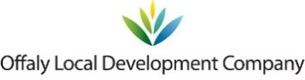

Offaly Local Development Company Support Agency Development Offaly Funding Ireland Leader (offalyldc.ie)

