Guidelines

Closing date: Monday 22nd January 2024 at 3pm
PURPOSE
The Professional Artists Support Scheme is designed to assist artists working across art mediums, i.e. visual art, performance, literature, dance, digital media, sculpture, theatre, music.
Artforms can include:
- Visual Artists– for the creation of new work / improving the quality of an artist’s practice, development of skills
- Music – to cover all forms of original music creation - i.e. classical, jazz, traditional, folk, rock, etc – for the creation of new work / improving the quality of an artist’s practice, development of skills
- Theatre – for the creation of new work / improving the quality of an artist’s practice, development of skills
- Dance – will cover all forms of dance performance and choreography, e.g. traditional, contemporary, ballet, etc. for the creation of new work / improving the quality of an artist’s practice, development of skills
- Literature – offered to writers of creative writing e.g. poetry, drama, fiction, script-writing (not applicable to writers of local historical research or documentary) for the creation of new work / improving the quality of an artist’s practice, development of skills

This award scheme seeks to support professional artists at any stage in their career, either born and who spent their formative lives in Offaly, or are currently living in Offaly, in the development of their own arts practice.

Aims:
- Supporting the development of artist’s practice
- Contributing to the growth of skilled artists living in the county
- Encouraging artists to live and work in Offaly
- Contribution to and impact on awareness of the arts in Offaly

WHAT WE WILL FUND
Artists may only apply under one category.

- Professional Development –
  - Further training, workshops, or master classes. Professional training such as workshops or a masterclass, mentoring, travel grants within Ireland and abroad related to training requirements. The applicant/s must clearly define how this research period will develop the artistic skill of the participants and/or artists involved.

  - Tyrone Guthrie Residency applications are max two- week per individual (dependent on number of applications received). Applicant will need to supply evidence of invitation from Tyrone Gutherie Centre or another nationally recognised residency to be considered for funding. The applicant/s must clearly define how this research period will develop the artistic skill of the participants and/or artists involved.

  - Time /costs related to the research of new works – a detailed proposal will be required to demonstrate proposed time relating to a research proposal. The applicant/s must clearly define how this research period will develop the artistic skill of the participants and/or artists involved.

- Creation of new work - To enable the creation of new work(s) (from any genre). Applicants must demonstrate on completion that the work will be presented, exhibited, published, performed and or disseminated or will be presented as a work in progress. The final report must demonstrate same. The award may cover and of the following:
- Research
- Arts Material costs – max award for materials assistance is €300
- Exhibition costs (in dedicated publicly funded arts spaces)
- Recording, (sound / digital) Publishing costs (by an independent recognised publisher)

- Reaching new audiences
  - To enable an artist to carry out research towards the development of audience / participant reach across communities not usually engaged in the arts, e.g. this might take the form of a pilot project sourcing or working with a community group.
  - Assistance for an arts practice / artist on projects that are working towards the development of audience / participant reach across communities not usually engaged in the arts. Projects must demonstrate a collaborative approach between the artist and the participants. Examples may include, but are not limited to, arts initiatives in informal education settings, healthcare, and community settings. They should inspire artists to engage, consult and collaborate with a community or place within county Offaly or provide opportunities for growth and development within the participatory arts sector. The applicant/s must clearly define how this collaborative/ participatory project will develop the artistic skill of the participants and/or artists involved.

FUNDING PROVISION

To Note: Funding offers usually range between 200 – 800 euro this is dependent on available budgets and proposals received. We may consider additional funding but only under exceptional circumstances and if budget allows. Payment of an Award is for specific activities as outlined in your application and cannot be transferred unless agreed in advance with the Arts Office.

ELIGIBILTY
Who can apply - Professional Artists at any stage in their career, either born and who spent their formative lives in Offaly or are currently living in Offaly. The artist is required to be on our Offaly Artist Database. The database is free and is not shared with any third party. All applicants must ensure they have a valid Tax Clearance number and access number if working within the community you are required to have public liability insurance and if working with children you are required to have child safeguarding training and child safeguarding policy/statement.

INELIGILITY
- Incomplete /late proposals, budgets and applications
- Education awards
- capital costs & purchase of mobile phones
- Application /activities for charity fund-raising purpose, for participation in a competition, trade stands or for primarily profit-making purposes.
- Film production - The development of conventional film, including mainstream short film, animation and documentary and work for television.

SELECTION CRITERIA
- Artistic ambition and quality of the proposal - 30
- Potential impact on individual’s artistic /career development - 30
- Competitive context and available resources - 20
- Applicant’s contribution to and impact on the arts in Offaly - 20

HOW TO APPLY
CLOSING DATE: Monday 22nd Jan 2024 at 3pm
This is an online only application through Submit.com. No hard copies or emails.
Link to online application is:

https://submit.link/29k

FILLING OUT THE FORM
You will be asked to fill in your contact details and upload one PDF document that must contain the following in order.
- A CV
- Proposal
- A detailed budget
- Quotes/Letter
- Links to Work or photos of Work

NOTES FOR APPLICANTS

- Please DO give yourself plenty of time to upload and complete the online application.
- Applications will only be accepted from individual professional artists as per our eligibility requirements – not groups or organisations.
- Proposals must be typed to include an indication of the concept and rationale, a clear budget and samples of the artist’s work.
- Only one application per individual artist will be accepted under one of the categories of this scheme.
- This award is not an education bursary.
- The award will be made in the context of a competitive assessment, the purpose of the award and selection criteria, and available resources.
- The award is for and relating to the calendar year 2024, it must not start prior to approval and if awarded drawdown must be prior to Monday 11th November 2024 at 3pm.
- For further queries please contact arts@offalycoco.ie

Funded by Offaly County Council and the Arts Council

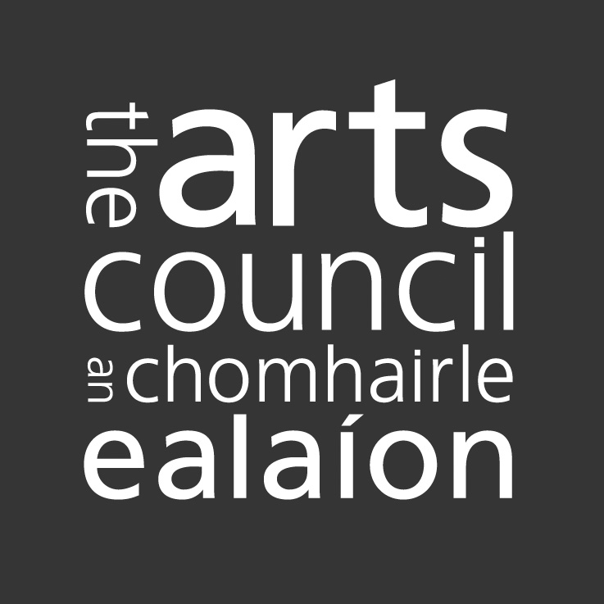

Definition of Professional Artist *‘A Professional Artist can be defined as someone for whom their art form is their whole-time occupation or who holds a third level qualification in their field of practice or has been paid and advertised as a solo or leading performer/exhibitor in a state funded institution or has been published or produced by a recognised publisher or theatre/film company or venue or is recognised as a professional by his/her peers and received recognition in the form of commendations, rewards, awards, grants, appointments to panels, etc.
In this application Art Materials / Equipment refers to the required resources needed by an artist across all art practices to enable the creation of new work: visual artist materials, e.g. paints, canvas etc, computer software to create art works, digital equipment (purchase of smart phones not included)
Definition of Professional Artist *‘A Professional Artist can be defined as someone for whom their art form is their whole-time occupation or who holds a third level qualification in their field of practice or has been paid and advertised as a solo or leading performer/exhibitor in a state funded institution or has been published or produced by a recognised publisher or theatre/film company or venue or is recognised as a professional by his/her peers and received recognition in the form of commendations, rewards, awards, grants, appointments to panels, etc.
Applicants should demonstrate through their application how the grant enable them to contribute to the arts in Offaly

