**Outdoor Public Space Scheme 2021**

**Lloyd Town Park Tullamore**

**New Caretakers Office and Toilets and Bandstand**

The Department of Department of Tourism, Culture, Arts, Gaeltacht, Sport and Media approved funding under the Outdoor Public Space Scheme 2021 to Offaly County Council for the suppliy and delivery of a new New Caretakers Office and Toilets and Bandstand in Lloyd Town Park Tullamore.

Tullamore Town Park, Lloyd Park, owned and managed by Offaly County Council, is an established local amenity and community resource in the capital town of Offaly. The park was established in 1987 and officially open to the public in 2008 following extensive refurbishment. The Park, an area of 5 hectares, has been rejuvenated throughout the years providing sports and recreation facilities for children and youths including a playground, skate park and basketball court and a place to walk, run and exercise including adult gym equipment and a tranquil and beautiful area to relax and socialize for the wider community. Lloyd Park has been awarded the Green Flag each year since 2016 and is a source of pride in the community.

The park has facilitated minor events over the years such and has been an invaluable resource during the COVID 19 crisis providing a space for people to meet outdoors to exercise and socialise. Lloyd Town Park is now an integral part of Tullamore Town and indeed the County as a focal point for recreation.

Offaly County Council aims to expand the use of the Park for cultural, arts and entertainment events. Arts events and live entertainment happen when people are drawn together around the artist or performer. COVID-19 challenges us to re-imagine how we deliver and experience art and live performance and one of those measures include new and innovative ways to bring people together outdoors.

In 2021 and 2022 Tullamore Municipal District organized a Halloween event in the Park with over 10,000 people visiting the Park over two days. The event PÚCA Spooka continued on in 2023 on the 28th and 29th October.

The installation of the Bandstand in the Park was informed by the Life Worth Living Report of the Arts & Culture Recovery Task Force to improve outdoor public spaces for arts & culture events and festivals, taking account of public health guidelines. The Project will enhance the outdoor space in the Park and facilitate year-round use. The Project is a place-making project that supports cultural endeavour and enables safe social activity. The space will made available for the use of arts & cultural activities and to arts & cultural organisations & individuals.

The existing toilet facilities in the Park were installed in 2008 and were no longer fit for purpose. The toilets will be replaced with two disability accessible toilets and a caretakers office including storage room.

Our vision for the outdoor covered entertainment area is for a space that can be readily available for OCC organized events and arts & cultural organisations & individuals. With an established stage, set up for lights and sound, the natural arena of the Park provides an ideal outdoor venue for culture events and festivals, entertainment and a place for people to meet and socalise outdoors. Our aim is that this space will be designed to be an amenity during the day, to sit and read or to meet and chat but easily transformed to host an event when needed.

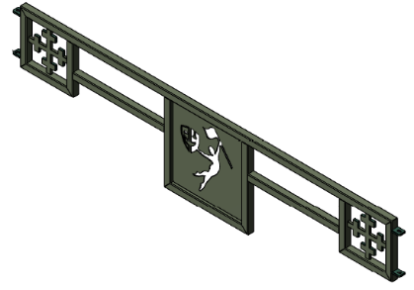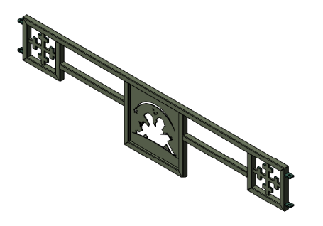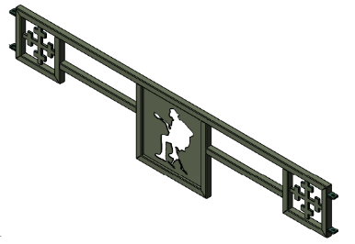

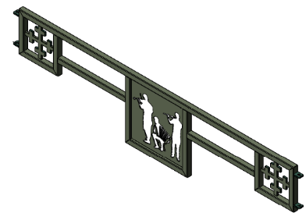

The Park has a water feature built in 2008. It is a favourite amenity in the Park encouraging people to sit alongside it. The water feature consists of a large shallow triangular pond divided into four sections by two pathways. Positioned on the central walkway are 42 clear water jets. The water feature is now 14 years old and Offaly County Council want to improve and enhance this feature to become part of the live entertainment area. We wish to enhance the fountain to become a multimedia feature to accompany the live entertainment.



