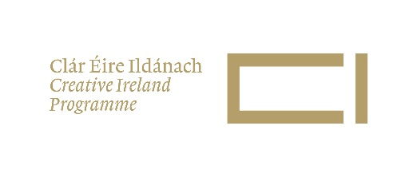 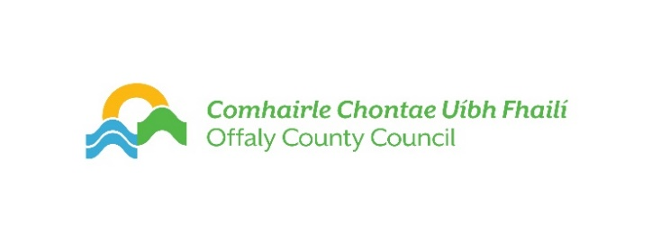

Offaly County Council

Creative Ireland Community Project Application Form 2025

1. Please read [Offaly Culture & Creativity Strategy 2023-2027.](https://www.creativeireland.gov.ie/app/uploads/2019/12/Offaly-1.pdf) All applications received must link with one of Offaly’s strategic priorities set out on pages 16 & 17 of this strategy.

2. Please submit the following application with all questions must be answered for your application to be fully assessed. The accompanying Grant Information sheet is to be read in tandem.

|  |  |
| --- | --- |
| Name of Community Group and main contact person |  |
| Email address for Community Group main contact person |  |
| Artist’s Name |  |
| Artistic Discipline |  |
| Email address for Artist |  |
| Phone number(s) |  |
| Website(s) if applicable |  |
| Aspect of Heritage to be Explored  (no. 1 on Grant information sheet) |  |
| Title of Proposed Project |  |
| Details of the Proposal (max 1,000 words)  (see no. 6 on Grant information sheet) |  |
| Is the project exploratory (incubator) or will the full project be delivered in 2025? |  |
| Timeframe  Key delivery dates to be listed (see no. 4 on grant information sheet) |  |
| Budget Sought  (see no. 3 on Grant information sheet)  Include full list of expenses here or on a separate excel spreadsheet.  Please indicate if you have applied for other sources of public funding for the same project and if so provide full details. |  |
| Bank Account/ sort code/ |  |
| IBAN number |  |
| Tax Clearance Number (must be in date at the time of grant draw down or payment cannot be issued) |  |

Please address your application to *Creative Ireland Open Call Community Project*

Email creative communities engagement officer at [kgray@offalycoco.ie](mailto:kgray@offalycoco.ie) (max size per email 10MB) by **noon Friday 21 February 2025**.